DEVELOPMENT OF LIGHT DETECTION AND RANGING (LIDAR) BASED AUTONOMOUS VEHICLE.
Dr. R. Rajkumar, S. V. Sai Akash Kumar, S. Yogaraj, S. Hariharasudhan.
Department of Mechanical Engineering, Mepco Schlenk Engineering College, Sivakasi 626005, India
________________________________________________________________
ABSTRACT Recent years have seen a substantial increase in interest in the creation of autonomous vehicles, with a variety of technologies being used to enhance their efficiency and safety. The construction and building of a vehicle model using a Lidar, Mecanum wheels, STM32 microcontroller, Raspberry Pi, and independent suspension are presented in this article. To determine a route for the vehicle to take, the Raspberry Pi first processes the 2D map of the surroundings produced by the Lidar sensor to identify obstacles. The vehicle can travel in any direction thanks to its Mecanum wheels, giving it more control and manoeuvrability. The Raspberry Pi is in charge of decision-making and general management of the car, and the STM32 microcontroller is used to interact with and operate the motors. The vehicle type also features independent suspension, which enhances stability and handling by enabling separate tyre movement. Better traction and balance are the outcome, particularly on uneven terrain. The vehicle model underwent controlled testing, and the findings were encouraging, displaying accurate obstacle recognition, fluid and exact movement, and effective navigation. However, additional testing in actual settings is required to gauge how well it performs in situations with greater challenges.
Keywords Obstacle detection, LIDAR, Raspberry pi, Arduino, Autonomous navigation, map-based navigation.
________________________________________________________________
- INTRODUCTION

  - PROBLEM DESCRIPTION:
To reduce human work and traffic accidents. And ensure a smooth and comfortable ride on all terrains. Helps in mapping the surrounding, detecting obstacles, and reaching the destination without hitting on the obstacles. Increase in manoeuvrability to turn in the tight corner without any problem.
  - OBJECTIVE:
Design and develop a full-scale down model in a ratio 1:8 autonomous surveillance car with 4WD (All Wheel Drive) and independent suspension system these are used to give a comfortable and move in all terrains. LiDAR (Light Detection and Ranging) detects the surroundings faster than other sensors and maps the surroundings. This LiDAR is RP LiDAR A1M8 which is a 360-degree sensing sensor. The Mecanum wheel (multi-directional wheel) is used to achieve greater manoeuvrability in small and tight corners that are hard for other vehicles to turn. With this one we can achieve higher mobility in storehouses/warehouses of industries where turning the vehicle in the sharp corner is quite difficult with a normal vehicle. Aluminium is used to machine chassis for reducing the overall weight of the vehicles. Further to reduce the weight of the vehicle we have removed some metals in some areas.
  - MECANUM WHEEL MOVEMENT:
Robots can be moved in any direction without altering their orientation using mecanum wheels, a form of the omnidirectional tyre. This is accomplished by mounting the wheels at a 45-degree angle to the direction of motion and angling the rollers around each wheel's diameter at the same angle. Mecanum wheels need to be arranged in a particular way to propel a robot. The wheels are typically mounted at a 45-degree angle to each point of the square or rectangle, with the wheels usually organised in a square or rectangular design. By adjusting the wheel's rotational speed and orientation, the automaton can travel in any direction.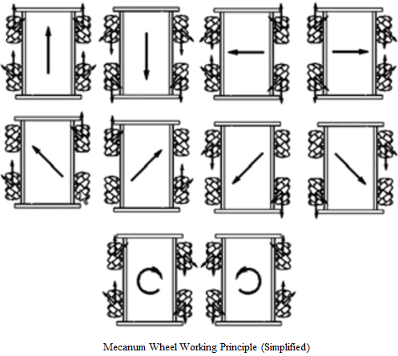
Figure 1
All four wheels are rotated similarly to travel forward or rearward. The robot can travel left or right by rotating the wheels on one side in one direction and the other side's wheels in the opposing direction. The wheels on one side of the robot are turned in one direction to rotate it in position, while the wheels on the other side are turned in the opposing direction faster. A mecanum wheel robot can be moved by various means, such as remote control, preprogramed movements, or sensors that pick-up obstacles or other items in the robot's route. Robots with mecanum wheels are frequently employed in applications such as warehouses, automation, mobile robotics, and unmanned vehicles.
  - RASPBERRY PI AND STM32F103RCT6:
The STM32F103RCT6 and Raspberry Pi are two distinct kinds of embedded devices that have various applications. A single-board computer called the Raspberry Pi is intended for workers, academics, and hobbyists who want to learn about circuits and computing. It utilises an ARM-based CPU and operates a Linux distribution. Numerous software programs, including video centers, web servers, and robotics tasks, can be operated on the Raspberry Pi. A microcontroller from the STM32 series intended for high-performance, low-power uses is the STM32F103RCT6. It has a broad variety of devices, such as ADCs, DACs, timers, and data ports, and is built on the ARM Cortex-M3 core. Automotive applications, industrial control systems, and other embedded systems that need exact timing and high dependability frequently use the STM32F103RCT6. The STM32F103RCT6 is a microcontroller with restricted resources that are intended for real-time apps, in contrast to the Raspberry Pi, which is a full-fledged computer with numerous interfaces and capabilities. In some situations, the two systems can work together, such as when the Raspberry Pi serves as the user interface and the STM32F103RCT6 manages the base hardware.
  - RP-LIDAR A1M8:
A 360-degree laser sensor called the RPLIDAR A1M8 is made for use in different robotic applications. It is manufactured by a company called RoboPeak and is a well-liked option for both pros and hobbyists. A spinning laser emitter is used by the RPLIDAR A1M8 to create a 360-degree image of the area. The laser estimates the distance to any obstacles within its field of view while scanning the surroundings at a frequency of 6,000 times per second. A 2D image of the world is created using the data obtained as a result. This map can be used for navigation and other things. With a range of up to 12 meters and a precision of 0.5 degrees, the RPLIDAR A1M8 is appropriate for a variety of tasks, including obstacle avoidance, indoor mapping, and robot localization. The software development kit (SDK) supplied by RoboPeak contains example code and frameworks for several programming languages, including C++, Python, and ROS. It uses a USB port to interact with a host computer or microcontroller. (Robot Operating System). Overall, a variety of robotic tasks can benefit from adding sophisticated detecting capabilities thanks to the RPLIDAR A1M8 laser scanner's strength and affordability.
  - METHODOLOGY:

Idea selection

Literature survey

Problem Identification

Material purchase

Design of chassis

Stress analysis in ANSYS

Fabrication

Assembly of circuit and chassis

Coding and Stimulation

Virtual and real life testing

Journal writting

Report writting

Poster making

Final execution

- LITERATURE SURVEY
Stelian-Emilian Oltean (2019) describes the creation of an independent mobile robot platform using an Arduino Uno and Raspberry Pi. The goal of the research is to combine the two platforms to give the robot better awareness and control abilities, allowing it to independently travel through an uncharted area [1]. A new method for real-time vehicle detection and monitoring using Raspberry Pi is suggested by Mallikarjun Anandhalli and Vishwanath P. Baligar (2018). For real-time car detection and monitoring, the research employs computer vision methods that can be applied to traffic control and security applications [2]. The use of LIDAR-based approaches for obstacle identification on the country and secondary roadways are covered by Carlino et al. (2016). In addition to offering insights into the creation of autonomous cars for rural regions, the research investigates the use of LIDAR devices in identifying obstacles [3]. An omnidirectional car using an active Omniwheel with a seamless perimeter is presented by Tatsuro Terakawa et al. in 2019. The research presents a unique omnidirectional wheel design that can be used for robotic applications because it allows for smooth motion in any direction [4]. The creation of sensor data fusion for obstruction recognition in an electric mini tractor is covered by Mandar Ashok Shinde et al. in 2023. To enhance obstruction recognition in real-time, the research suggests a sensor fusion method that integrates data from various sensors, such as LIDAR and ultrasonic sensors [5].
These studies show the value of combining various technologies for enhanced detection and control skills in embedded and robotic systems. Autonomous navigation, obstacle recognition, and car tracking have all been demonstrated to be possible with the help of computer vision, LIDAR sensors, and sensor fusion methods for a variety of uses.
- WORKING
The parts are first put together on top of the aluminium foundation plate. The data from the LIDAR is first analysed and mapped into two dimensions. The raspberry pi 4v is then given the 2D-mapped environment as input. The car is taken into account as the measurement's origin point, and the raspberry pi gauges the distance between that line and the nearby area's 2D map. At a distance of 0.3 meters, the raspberry pi finds the obstruction. Signals are sent to the STM32, which operates the stepper motor at the necessary locations after the obstruction is detected.
- DESIGN CALCULATION AND MODELS

  - VEHICLE CALCULATION:
The calculation of torque, rpm, and power for the vehicle is crucial in determining the appropriate motor for the robot. In this calculation, the weight of the vehicle, its speed, and the radius of the wheel is taken into consideration. The weight of the vehicle is determined to be 15kg, and its speed is 2kmph or 0.5556m/s. The radius of the wheel is determined to be 50mm or 0.05m.
Weight of the vehicle (w) = 15kg
Vehicle speed (v) = 2kmph => $\frac{2}{3.6}$m
=> 0.5556m
Radius of the wheel (r) = 50mm => 0.05m
Using the weight of the vehicle and the gravitational acceleration,
Force (F) = $w×g$ = $15×9.81$
= 147.15N
The force acting on the vehicle is determined to be 147.15N.
Using this force and the radius of the wheel,
Torque ($τ$) = $F×r$ = $147.15×0.05$
= 7.3575Nm
The estimated torque exerted on the wheel is 7.3575Nm.
By splitting the vehicle's speed by the tyre's radius, one can determine the angular motion of the wheel,
Angular velocity ($ω$) = $\frac{v}{r}$ = $\frac{0.5556}{0.05}$
= 11.1111 rad/s
=> $\frac{60 × 11.1111}{2 × π}$rpm
= 106.1033rpm
which gives 11.1111 rad/s or 106.1033rpm.
Finally, the power needed to drive the wheel is calculated by multiplying the torque by the angular velocity,
Power (P) = $τ × ω$
= $7.3575×11.1111$
= 81.75W
which gives 81.75W. These calculations are important in selecting the right motor for the robot to ensure that it can move efficiently and effectively.
Motor specifications:
The motor specifications provide crucial information regarding the motor's performance and suitability for a particular application.
Rated Voltage : 12 V
No-load Current : 70 mA
Rated Current : 410 mA
Rated Torque : 1.2 kg-cm
=> 0.1177Nm
Shaft Diameter : 6 mm
Gear Ratio : 20:1
Speed :225rpm
The motor's ability to deliver the necessary power and speed for the vehicle's motion depends heavily on these specs. The motor's 12 V nominal voltage indicates the voltage needed to run it effectively, and the no-load current shows how much current the motor uses when there is no weight attached. The motor's capacity to operate under a burden is indicated by the maximum current and torque, whereas the motor's output speed and torque are determined by the gear ratio and speed.
Overall, the motor specifications are crucial for choosing the right motor for a specific purpose, guaranteeing effective operation and top performance.

  - BATTERY CALCULATION:
A critical component of developing a mobile robot base is battery computation. It guarantees that there will be enough electricity to operate all of the robot's gadgets and parts for a predetermined amount of time. In this instance, the actuator, RP LiDAR A1M8, Raspberry PI 4B 8GB, and STM32F103RCT6 required total power and Ah of battery.
The RP LiDAR A1M8 needed 350 mA while the motor's maximum current was discovered to be 1640 mA. The STM32F103RCT6 used 50mA, and the Raspberry PI 4B 8GB required 1010mA. Therefore, it was determined that 3050mA would be the overall current required for all of the instruments.
To calculate the required energy (E) for the battery,
E $=V×A×h$ (Hours) = 12V x 3050mA x1.5h
E = 54.9W
Considering a ride time of one-and-a-half hours, the required energy was calculated to be 54.9W.
The next step was to calculate the battery’s required Ampere-hours (Ah).
Ah = $\frac{E}{V}$ = 54.9/12
= 4.575 Ah
Where E is the energy calculated in the previous step, and V is the voltage of the battery. In this case, a 12V battery was assumed. Therefore, the required Ampere-hours (Ah) for the battery were found to be 4.575Ah.
In conclusion, the battery calculation is essential to ensure that the mobile robot platform has sufficient power to run all the devices for a specified duration of time. In this case, the total current and Ah of battery needed were calculated to be 3050mA and 4.575Ah, respectively, for a one-and-a-half-hour ride.
  - SPRING CALCULATION
A spring is a mechanical device that is used to store and release energy. It is typically made of a flexible material and is designed to withstand and recover from deformation. To design a spring, it is important to take into account various factors such as the material used, the load acting on the spring, the deflection of the spring, and the number of active coils. In this scenario, we are given the torsional stress, deflection, mean diameter, and material used for a spring made of stainless steel. We can use this information to calculate the wire diameter, number of active coils, and spring constant.
1.Torsional stress ($τ$) = 400mpa.
2.Deflection of the spring(ʆ) =20mm.
3. Mean diameter (D) = 16mm.
4.Free Length = 70mm.
5.Material used🡪Stainless steel 🡪Elastic Modulus (G)=7.35*10^4 N/mm²
Wire diameter (d) 🡺d³ = $\frac{8×D×P}{π×τ_{0}}$
$=\frac{8×16×150}{π×400}$
= 2.48mm.
Where P is the load acting on the spring.
Number of active coils (N_{a}) $=\frac{G×d^{4}×δ}{8×D^{3}×P}$
$= \frac{7.35×{10}^{4}×{2.49}^{4}×20}{8×{16}^{3}×150}$
=11.496
where G is the elastic modulus of the material, ʆ is the deflection of the spring, and D is the mean diameter. From the given data, we get the value of Na as 11.496.
Spring Constant (k) $=\frac{G×d^{4}}{8×Na×D^{3}}$
$=\frac{7.35×{10}^{4}×{2.48}^{4}}{8×11.496×{16}^{3}}$
= 7.5N/mm
where d is the wire diameter and G is the elastic modulus of the material. From the calculated values of d3 and Na, we get the value of the spring constant as 7.5N/mm.
Thus, the torsional stress is $τ$ = (8*D*P)/($π$*d³)
= (8*16*150)/(π*2.49³)
= 395.87mPa
where D is the mean diameter and d is the wire diameter. From the calculated values of D, d3, and P, we get the value of torsional stress as 395.87mPa.
We can conclude that the stress is under the limit since the maximum stress of stainless steel is 695mPa. Therefore, the design of the spring is safe and appropriate for the given load and deflection.

  - DESIGN DIAGRAMS:
Design diagrams are an essential aspect of any design project. They provide a visual representation of the components of the project and how they are put together. In this design project, there are five parts: two types of links, two supports, a base plate, and a wheel hub. All the parts are made of Aluminum sheets and blocks(AL 6061), following the standard ASTM B209.
The links are designed with and without an attachment for suspension. Figure 1 shows the drawing of these two types of links. For each side of the vehicle, two of each links are needed, and a total of eight of each links are needed. The links are designed using Solidworks for the shown dimensions in figure 2.
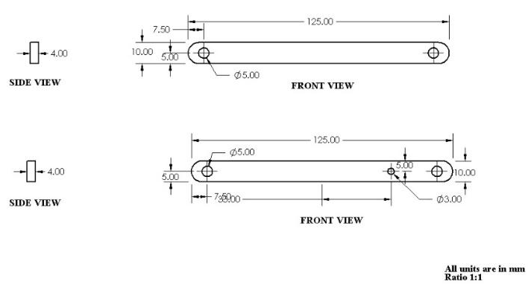
Figure 2: LINKS
Similarly, two supports are designed: one for the bevel gear and the other for the wheel. Figure 3 shows the drawing of these supports. A total of four of each support is needed, which are also designed in Solidworks for the shown dimensions in figure 3.
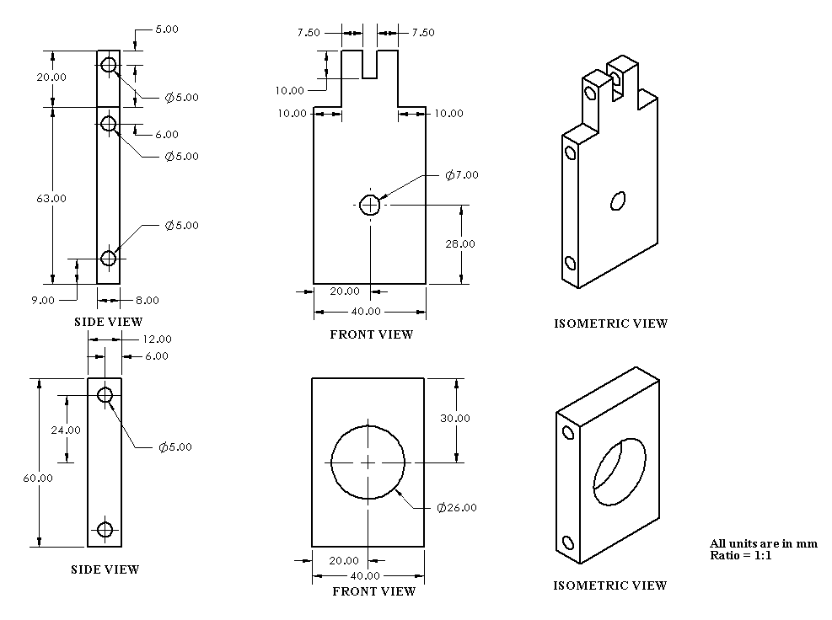
Figure 3: WHEEL AND GEAR SUPPORTS
The base plate is of 4mm thickness, as shown in Figure 4. One base plate is needed for the project. The plate is cut down using a handheld cutter, which helps in reducing the cost of machining compared to machining in a CNC milling machine.
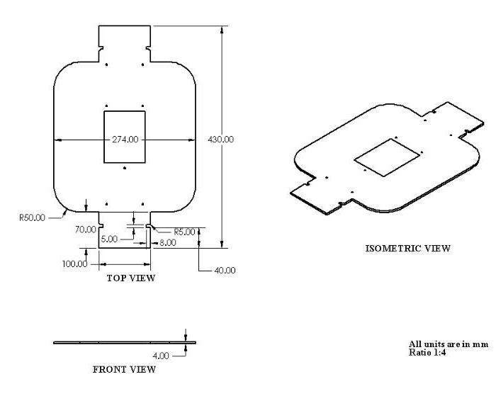
Figure 4: BASE PLATE
The wheel hub is designed to attach the wheel to the stepper motor. It is machined in a horizontal lathe and then drilled.
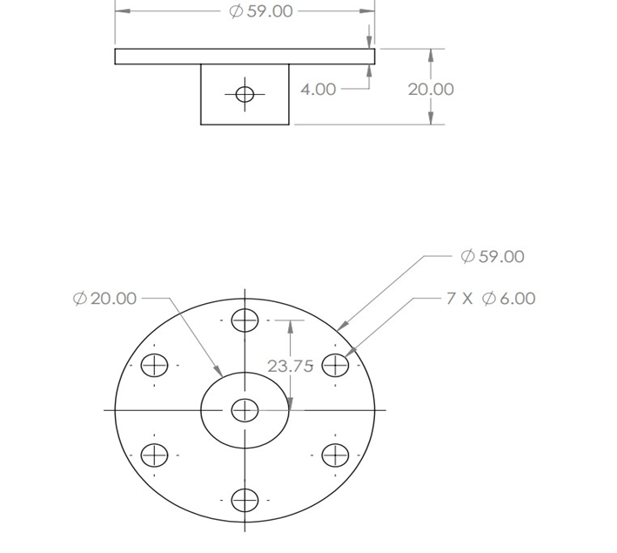
Figure 5 Wheel Hub
All the above parts are assembled in solid works assembly, as shown in Figure 4 Assembly of Vehicle. For each wheel, a wheel-support and a bevel-support are connected by two links with suspension attachment on top, while another type of at the bottom as shown in figure 4. The bevel support is welded to the base plate using MIG welding with shielding gas CO2.
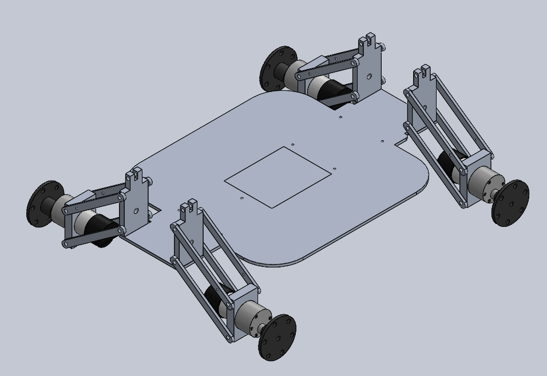
Figure 6: ASSEMBLY OF VEHICLE
- ANALYSIS OF THE MODEL

  - ANALYSIS OF THE MODEL USING SOLIDWORKS:
To analyze the model, Solidworks simulation was used to calculate the stress and displacement in the vehicle while it is at rest. The von Mises stress contour plot (Figure 8) and displacement contour plot (Figure 9) were simulated.
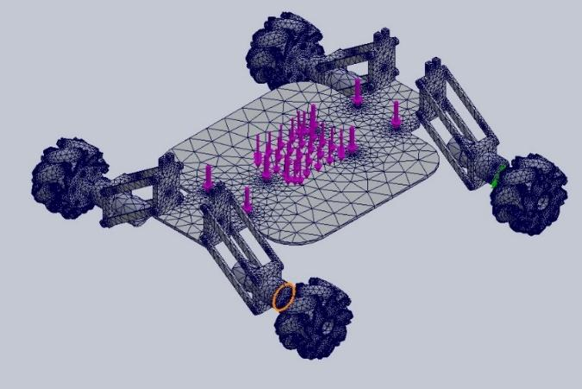
Figure 7 Mesh of Assembly
The mesh of the assembly is shown in Figure 7, which is the finite element analysis mesh that was used for the simulation.
The von Mises stress contour plot (Figure 8) shows the distribution of stress in the vehicle due to its weight. The maximum stress occurs at the suspension points and the welds connecting the supports to the base plate, as expected. However, the stress levels are well below the yield strength of the material, indicating that the design is safe and can withstand the weight of the vehicle.
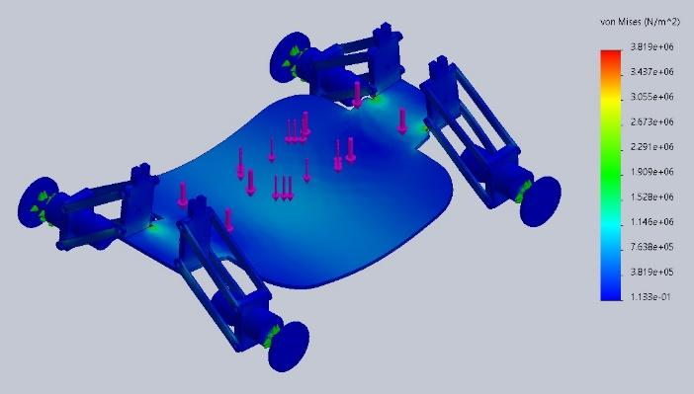
Figure 8: VON MISES STRESS CONTOUR PLOT
The Yield strength calculated from the stress analysis is 2.757$×{10}^{7}\frac{N}{m^{2}}$.
The displacement contour plot (Figure 9) shows the displacement that occurred in the chassis due to the weight of the vehicle. The maximum displacement occurs at the suspension points, but again, the levels of displacement are within acceptable limits and do not pose any safety concerns.
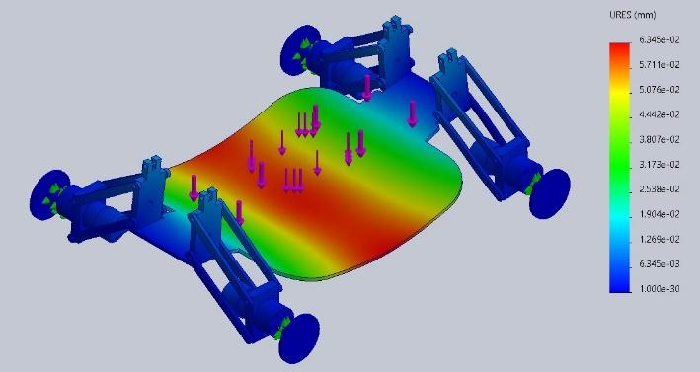
Figure 9: DISPLACEMENT CONTOUR PLOT
Overall, the analysis of the model using Solidworks simulation indicates that the design is safe and can withstand the weight of the vehicle without experiencing excessive stress or displacement.

- REFERENCES
- Stelian-Emilian Oltean, (2019), Mobile Robot Platform with Arduino Uno and Raspberry Pi for Autonomous Navigation, “Procedia Manufacturing”, Volume 32, Pages 572-577, ISSN 2351-9789.
- Mallikarjun Anandhalli, Vishwanath P. Baligar, (2018), A novel approach in real-time vehicle detection and tracking using Raspberry Pi, “Alexandria Engineering Journal”, Volume 57, Issue 3, Pages 1597-1607, ISSN 1110-0168.
- Carlino, A., Altomare, L., Darin, M., Visintainer, F., Marchetto, A. (2016). Automotive LIDAR-Based Strategies for Obstacle Detection Application in Rural and Secondary Roads. In: Schulze, T., Müller, B., Meyer, G. (eds) “Advanced Microsystems for Automotive Applications 2015”, Lecture Notes in Mobility. Springer, Cham.
- Tatsuro Terakawa, Masaharu Komori, Yuuta Yamaguchi, Yugo Nishida, (2019), Active omni wheel possessing seamless periphery and omnidirectional vehicle using it, “Precision Engineering”, Volume 56, Pages 466-475, ISSN 0141-6359.
- Mandar Ashok Shinde, Mohammad Rafiq B Agrewale, Yogesh Krishan Bhateshvar (2023), Development of sensor data fusion for obstacle detection for electric mini tractor, “Materials Today: Proceedings”, Volume 72, Part 3, Pages 1206-1211, ISSN 2214-7853.

